Homework 5 Depth from Focus

Yongchi Zhang

**1. Implement an android function to capture a focal stack**

The code are in the zip files.

Focus distance: 1.0

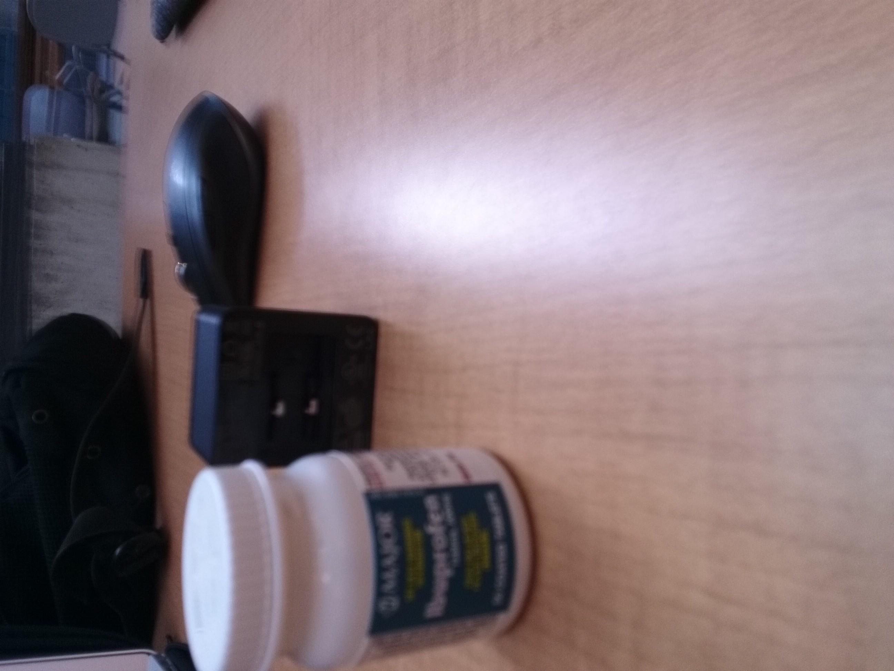

Focus distance: 1.5

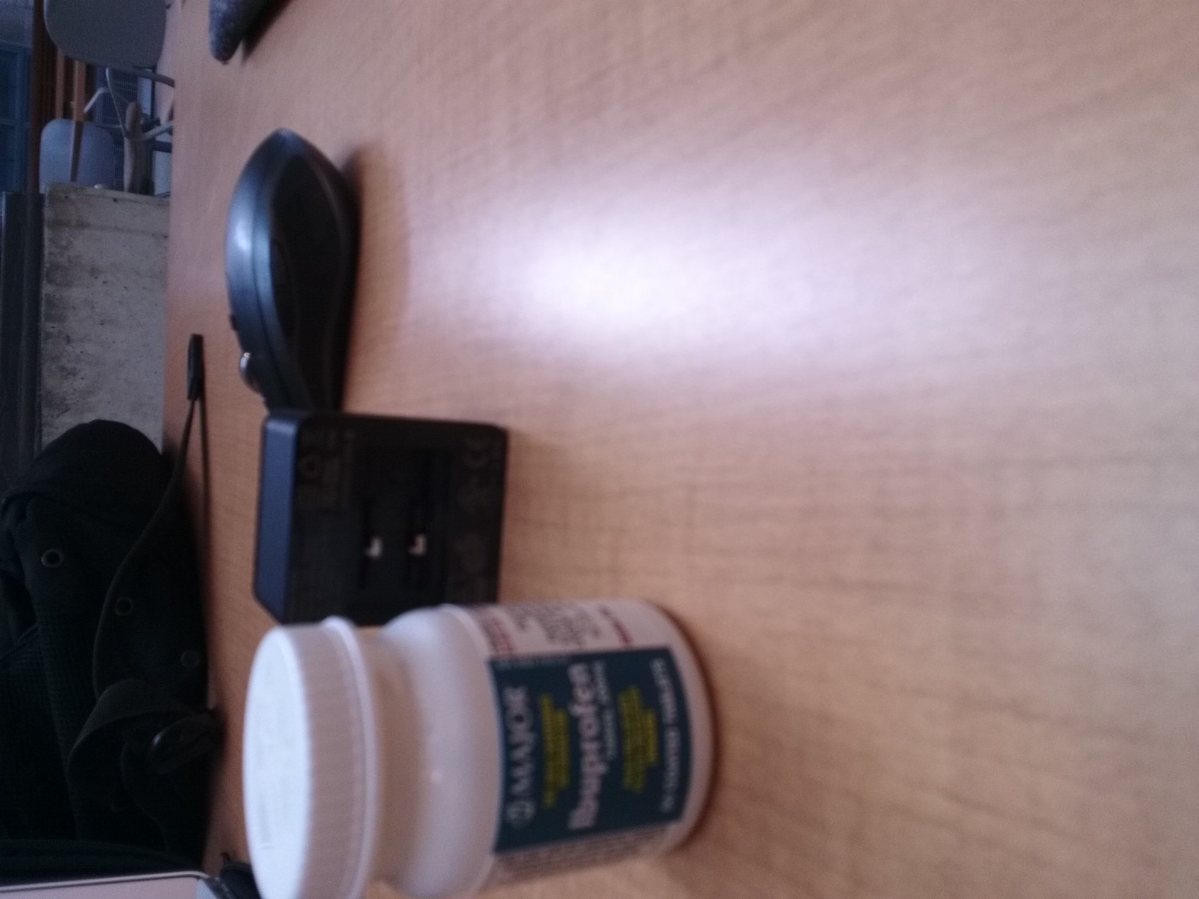

Focus distance: 2.25

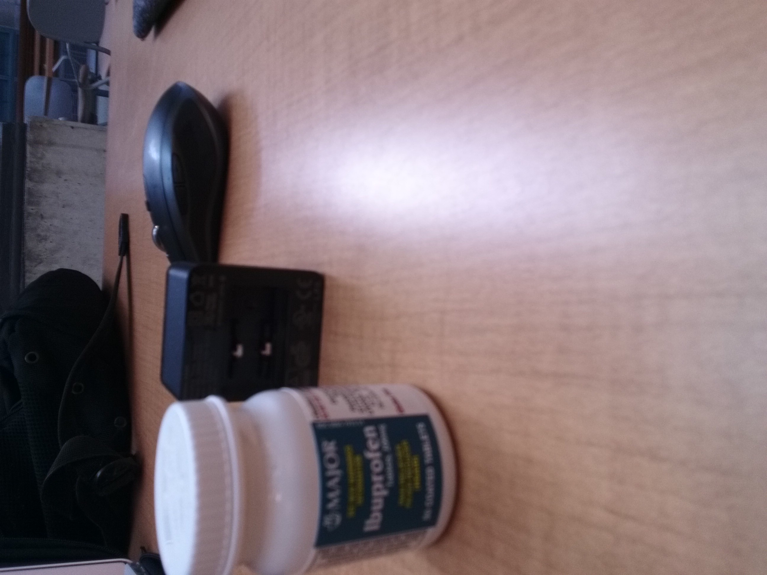

Focus distance: 3.375

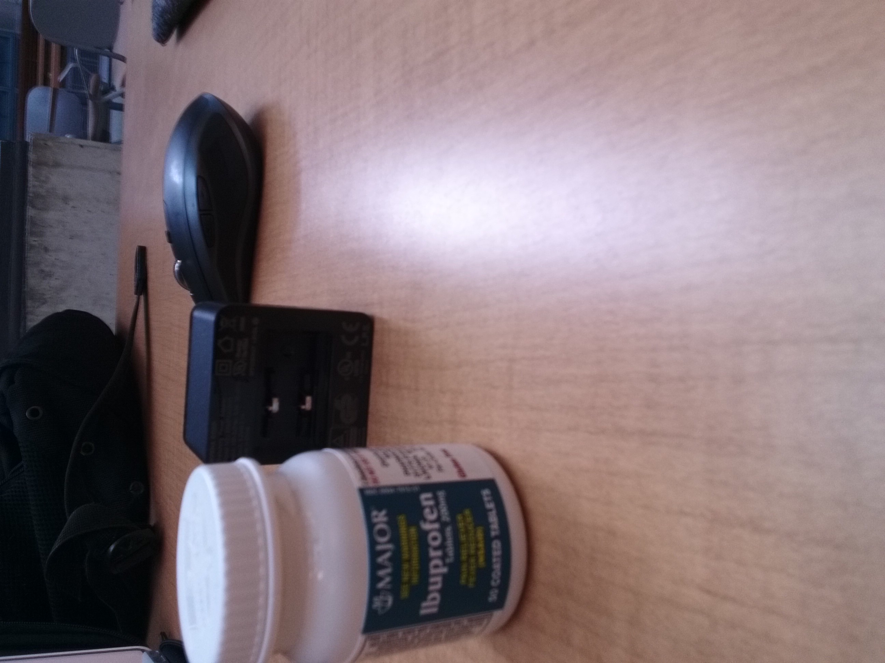

Focus distance: 5.0625

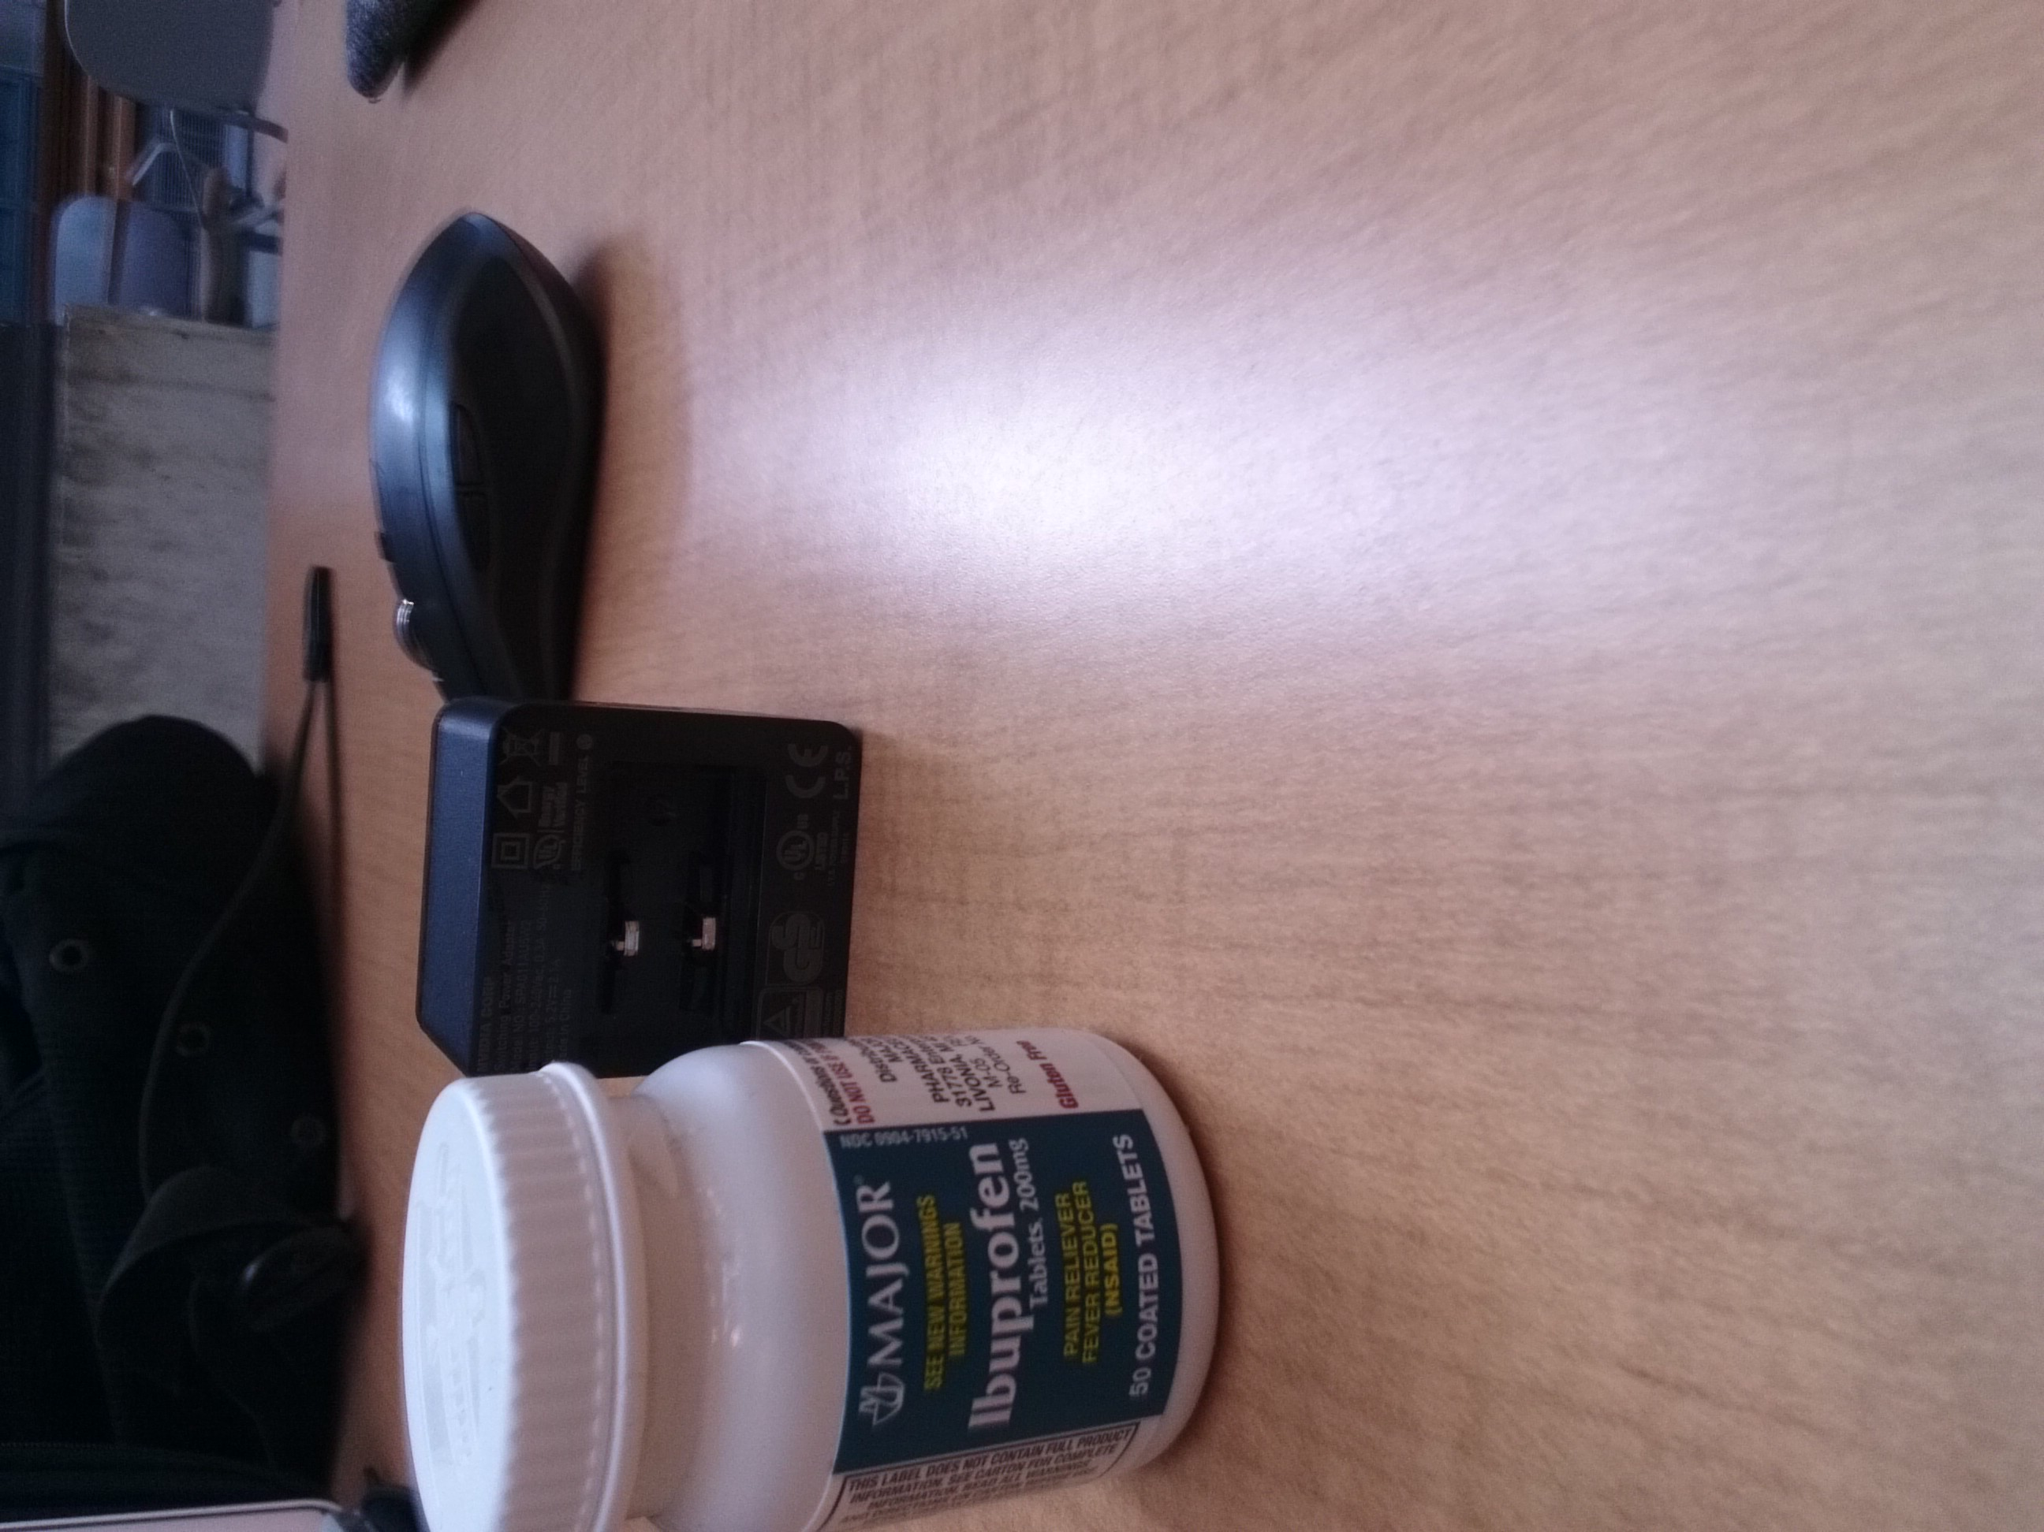

Focus distance: 7.59375

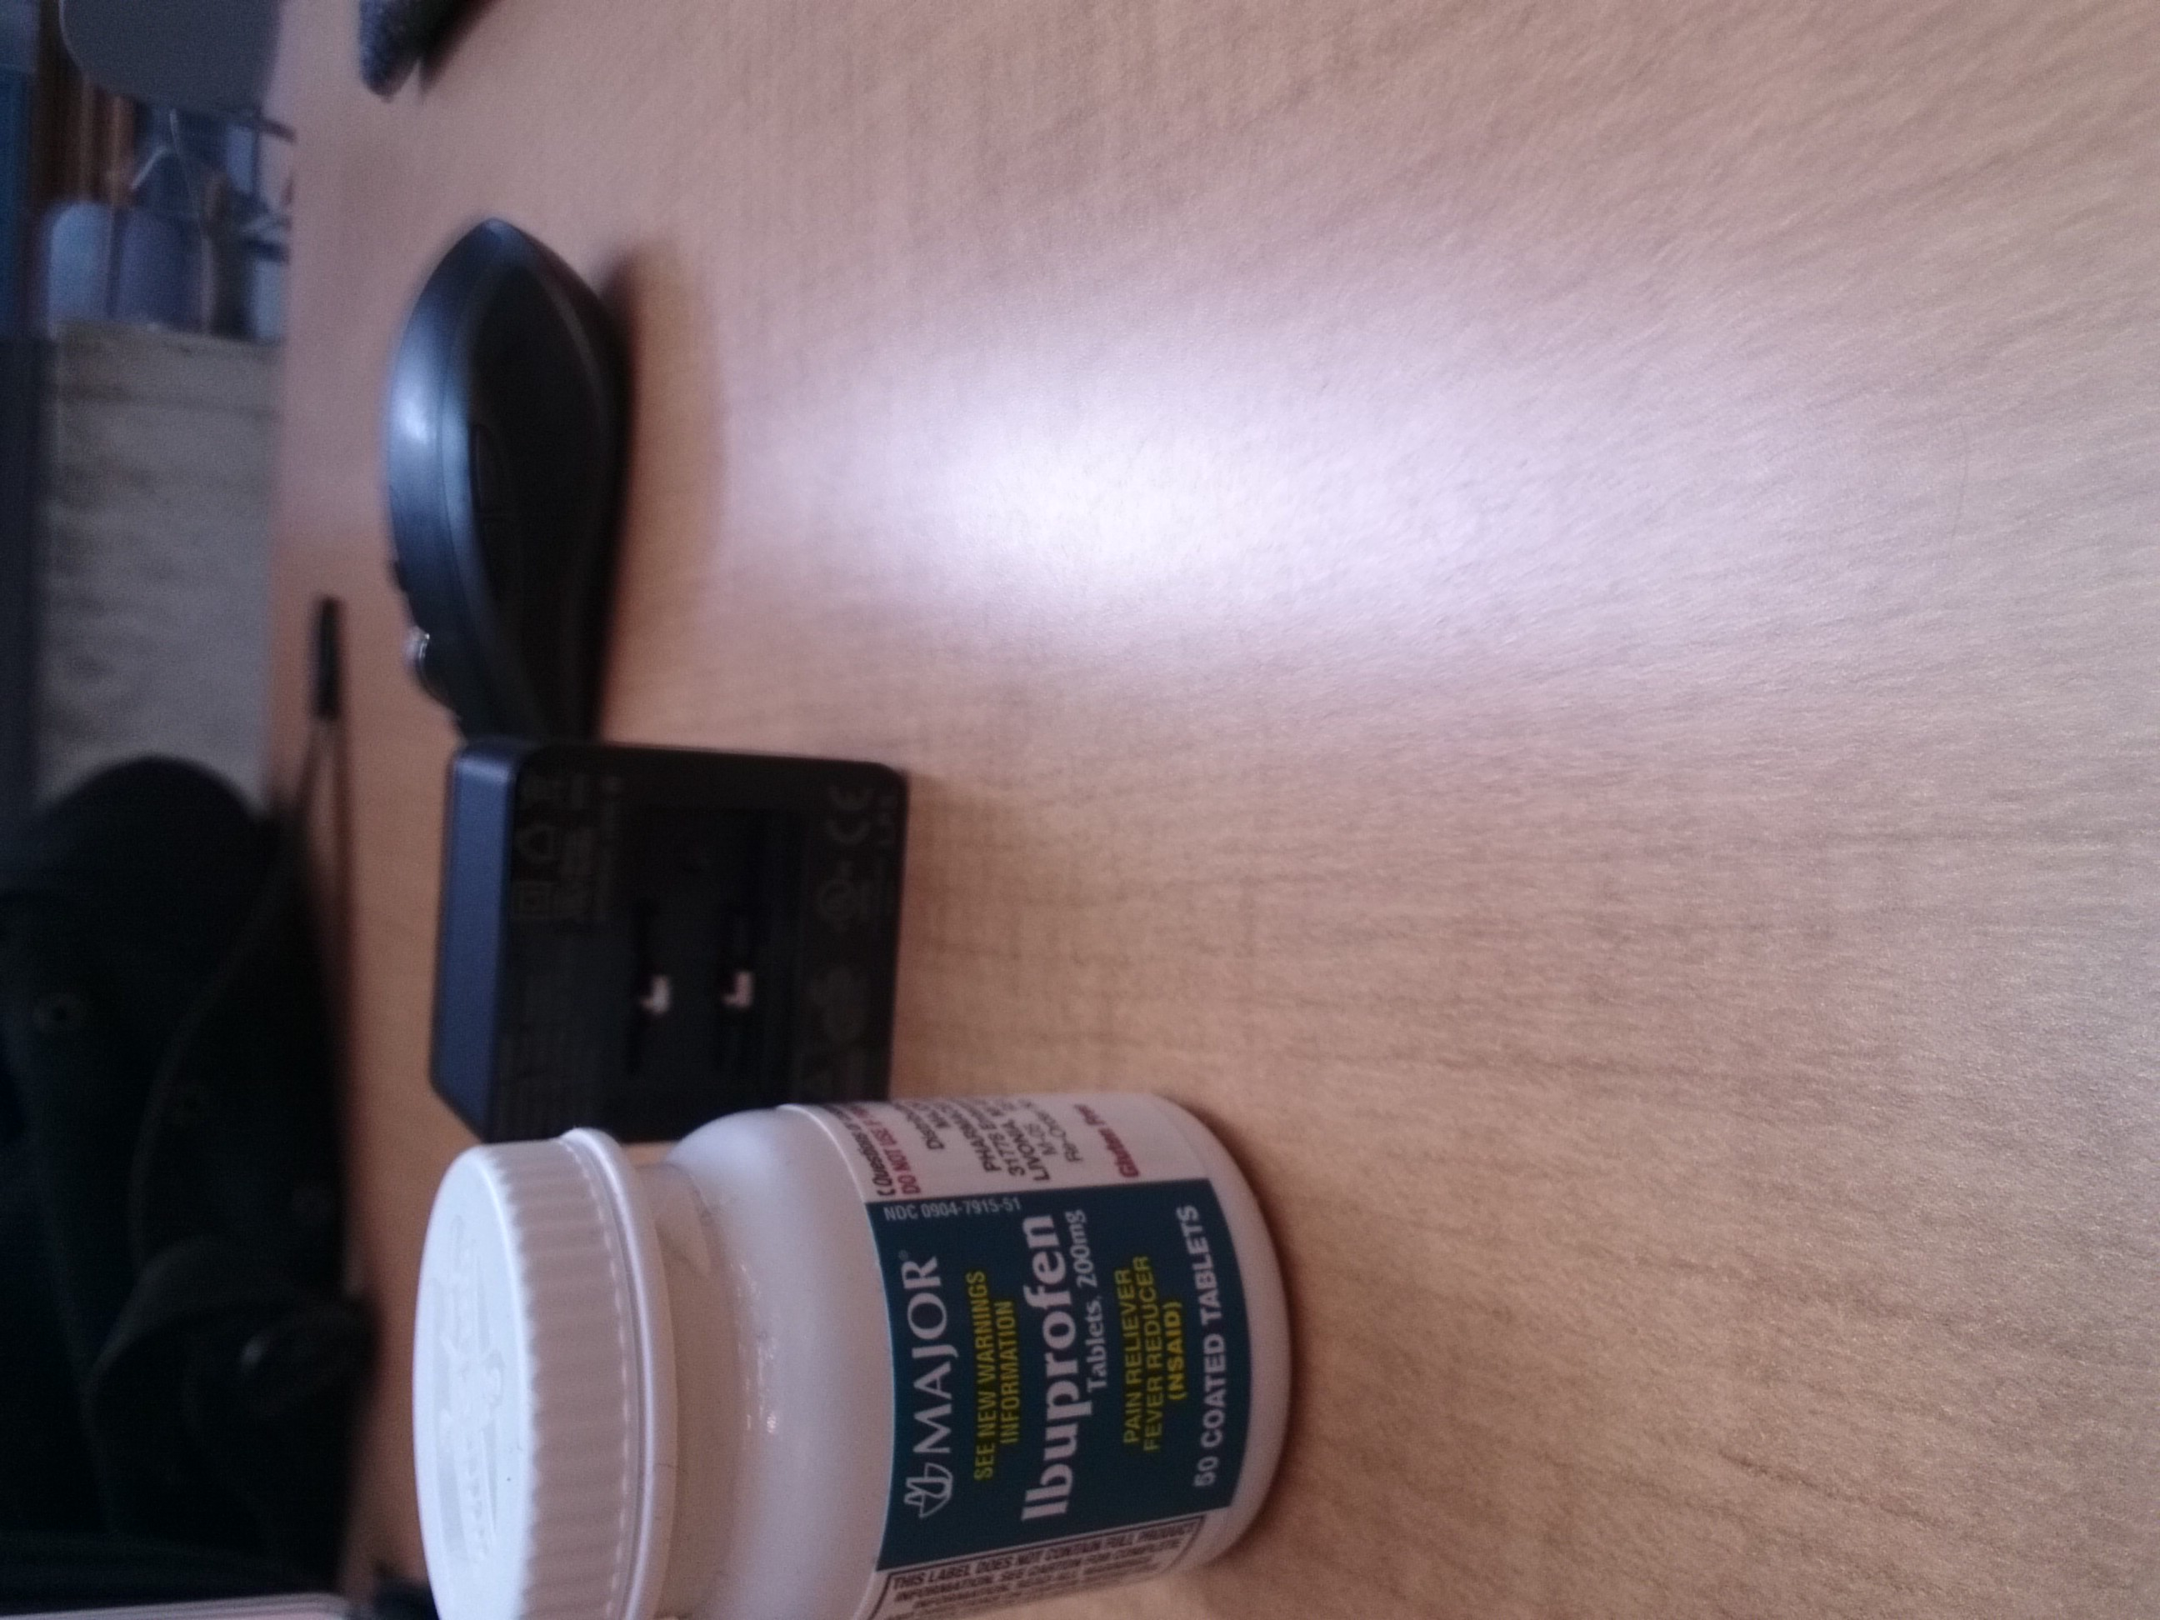

**2. Calibrate your focal stack**

The matlab code is in the zip file.

**3. Compute a depth map from the focal stack**

A depth index map computed from the focal stack:

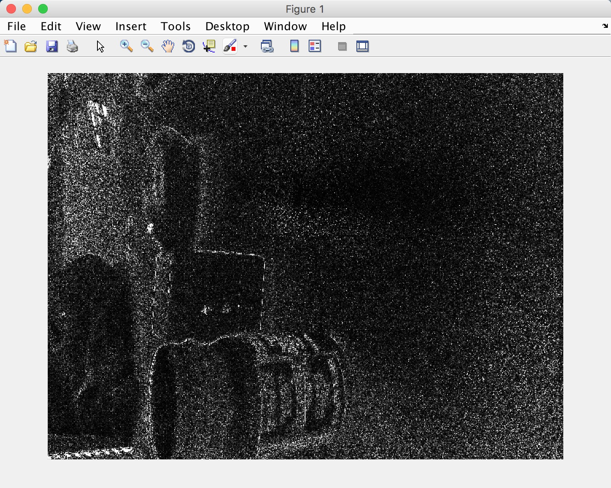

**4. Recover an all-focus image of the scene**

All-focus image:

